**Observation**

Inspection was undertaken at the subject property in the presence of the Insured to which the following tree impact damage was noted:

1. We have provided ***Figure 2*** below, schematic floor plan of the subject Horse Stable building, highlighting the elements and areas sustained tree impact damage.

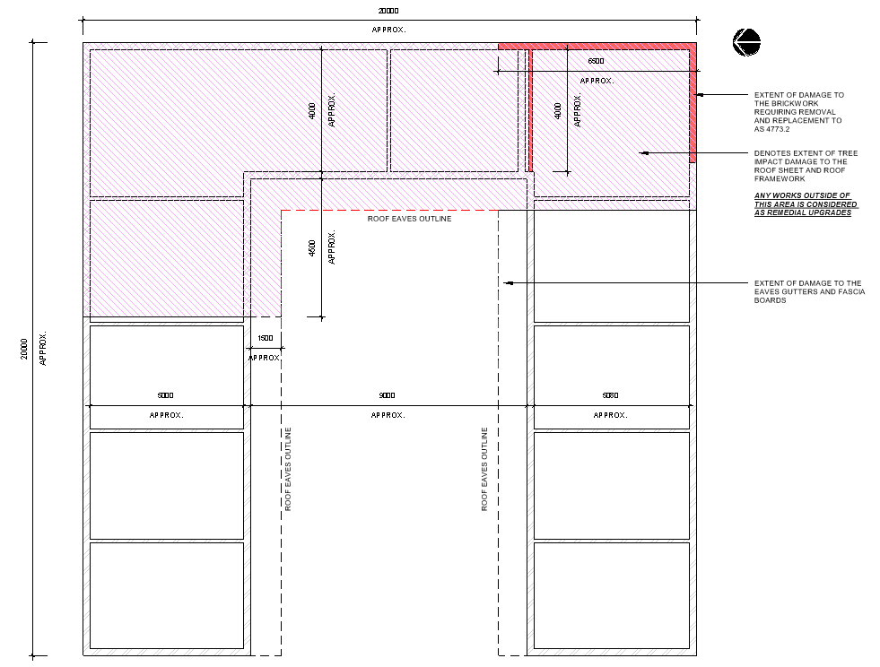

Figure 2 – Schematic Floor Plan of the Subject Horse Stable Building

1. From our inspection, we noted damage to the following building elements, which has occurred as a result of experienced tree impact.

## Roof Cladding

1. From our inspection, we noted the section of roof cladding corresponding to the southeast corner of the Horse Stable building (about the direct point of impact) has collapsed, which had already been removed from the site. **Images 3 - 5**
2. Moreover, we noted the roof sheeting along the eastern alignment and northeast corner of the Horse Stable building as highlighted in ***Figure 2*** has sustained significant tree impact damage. **Images 3 - 5**
3. Moreover, we noted the remaining section of the roof sheeting to be generally in an aged and dilapidated condition consistent with general wear and tear over a prolonged period of time and unrelated to the tree impact.
4. In saying that, in our opinion, the existing roof sheeting has surpassed its service life, and requires complete removal and replacement in accordance with *AS 1562.1* requirements.
5. As such, to achieve a warrantable repair, we advise for complete removal and replacement of the existing roof sheeting with a new Colorbond roof cladding, inclusive of all associated flashing and safety mesh in accordance with *AS 1562.1 - Design and Installation of Sheet Roof and Wall Cladding* and manufacturer’s specifications.
6. In proportioning the extent of resultant tree impact damage to the roof sheeting, we estimate **approximately 45% (110 m2 GFA)** of the total roof area (245 m2 GFA) has sustained damage as a direct result of tree impact.
7. In undertaking the above, an application for a Development Application or Complying Development Certificate (CDC) will be required for the roof reconstruction works, in view of obtaining Development Consent (DC) and subsequent Construction Certificate (CC).

## Roof Timber Framework

1. From our inspection, we noted significant damage to a number of roof timber rafters and battens along the eastern alignment of the roof framework consistent with tree impact damage. **Images 6 - 12**
2. Generally, we noted evidence of rot and deterioration of the roof timber members, which is consistent with expected long-term environmental degradation.
3. In our opinion, such deterioration has developed over an extended period of time and has resulted in the progressive decrease of the structural integrity and capacity of the timber members.
4. Furthermore, according to our assessment, we identified numerous non-compliance issues with the roof tie-down provisions against current Australian Building Codes and Standards, which is consistent with the age of the building.
5. In saying that, in our opinion, in achieving a warrantable repair and to assure long-term serviceability of the roof framework, we recommend the entire roof timber framework will require removal and upgrades to achieve compliance with current relevant Australian building codes and standards.
6. Having said that, we estimated that **approximately 10% of the total roof framework** has been damaged as a result of the claimed tree impact, as such, in our opinion, the cost of resultant damage repairs equates to only 10% of the total cost should the Insured wishes to replace the entire roof framework.

## Gutters and Fascia

1. We noted tree impact damage to the eaves gutters and fascia boards and eaves around the location of impact. **Images 13 - 15**
2. From our inspection, we noted that the remaining eaves gutters and fascia boards are in dilapidated condition due to long-term wear and tear and lack of regular upkeep.
3. Moreover, we were unable to identify any downpipe within the entire length of eaves gutters.
4. In saying this, in providing a warrantable repair, we recommend complete removal and replacement of the abovementioned building elements inclusive of new downpipes in accordance with AS 3500.3 and NCC BCA 2019 requirements.
5. We noted that the extent of resultant tree impact damage within the aforesaid building elements is estimated to be **approximately 20Lms**.

## External Brickwork

1. According to our inspection, we note the existing brickwork about the immediate point of tree impact corresponding to the southeast corner of the Horse Stable building has been significantly damaged, requiring removal and replacement in accordance with *AS 4773 – Masonry in Small Buildings*. Refer to ***Figure 2*** for the extent of damage within the brickwork. **Images 16 & 17**
2. Based on our assessment, in our opinion, the extent of damage to the brickwork is only contained to the immediate point of impact and the remaining brickwork appeared to be unaffected as a result of the tree impact. **Images 18 & 19**

## Electrical Services

1. We noted tree impact damage to the exiting floodlight affixed to the brickwork within the mid-section of the eastern alignment, which requires removal and replacement inclusive of all associated wiring, fixings and connections to match the existing. **Image 20**

**Discussion**

NA

**Conclusion**

We have provided **Table 1** below to outline the observed tree impact damage to each building elements within the subject Horse Stable building:

| **Observed Damage** | **Comments and Discussion** |
| --- | --- |
| **Roof Cladding** | We noted tree significant tree impact damage to the roof sheeting corresponding to the northeast, eastern and southeast alignment of the Horse Stable building.  From our inspection, the remaining section of the roof sheeting was noted to be in aged and dilapidated condition due to general wear and tear over a prolonged period of time.  In saying that, to achieve a warrantable repair, we recommend for complete removal and replacement of the roof sheeting within the entire roof surface in accordance with *AS 1562.1* and manufacturer’s specifications.  In proportioning the extent of resultant tree impact damage to the roof sheeting, we estimate **approximately 45% (110 m2 GFA)** of the total roof area (245 m2 GFA) has sustained damage as a direct result of tree impact.  Such works will require application for DA/CDC in view of obtaining Development Consent (DC) and subsequent Construction Certificate (CC). |
| **Roof Timbre Framework** | Based on our observation, we noted number of roof timber battens and rafters within the eastern alignment of the roof have sustained tree impact damage, beyond repair and require removal and replacement.  From our inspection of the undamaged section of the roof framework, we noted evidence of rot and deterioration of the roof timber members, which is consistent with expected long-term environmental degradation.  Moreover, we a noted number of non-compliance issues with regard to roof tie-down provisions relative to current Codes and Standards requirements.  Subsequently, in our opinion, in providing a warrantable repair, we advise for the entire roof timber framework to be removed and replaced inclusive of necessary tie-down upgrades to achieve compliance with current relevant Australian building codes and standards.  Having said that, we estimated that **approximately 10% of the total roof framework** has been damaged as a direct result of the claimed tree impact. |
| **Gutters and Fascia** | We noted tree impact damage to the eaves gutters and fascia boards and eaves around the location of impact.  We further noted that the remaining eaves gutters and fascia boards are in dilapidated condition due to long-term wear and tear and lack of regular upkeep.  We were unable to identify any downpipe within the entire length of eaves gutters.  Considering the above, in our opinion, the above building elements will warrant complete removal and replacement in line with relevant Australian Standards and NCC BCA 2019 requirements in providing a warrantable repair.  In our opinion, **approximately 20Lms** of the total eaves guttering and fascia board has been damaged as a result of claimed tree impact. |
| **External Brickwork** | The existing brick walls corresponding to the direct point of tree impact about the southeast corner have sustained significant tree impact damage, which requires complete removal and replacement in accordance with AS 4773. |
| **Electrical Services** | We noted tree impact damage to the exiting floodlight affixed to the brickwork within the mid-section of the eastern alignment, which requires removal and replacement inclusive of all associated wiring, fixings and connections to match the existing. |